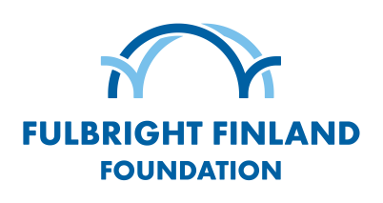

TRAVEL AND U.S. BANK INFORMATION

PLEASE TYPE YOUR ANSWERS!

NAME:

ACCOMPANYING FAMILY MEMBERS

- Name and date of birth of all accompanying family members:

TRAVEL INFORMATION

- Departure date and place in the U.S.:
- Arrival date in Finland:

- Planned departure date from Finland:

U.S. BANK INFORMATION FOR INTERNATIONAL PAYMENT

Your travel allowance will be paid to your U.S. bank account. Please make sure that your bank allows direct international payments. If you bank does not allow direct international payments, please ask instructions from your bank on how to proceed in this case.

- Account holder’s name exactly as written in the Bank’s files:
- Full name of your bank:
- Address of your bank:
- Your bank account number:
- BIC/Swift code (Routing code):

Please double check that you have typed all the information correctly and return the form to your program coordinator at Fulbright Finland.

